-- EXERCISE 6

-- 1. Order all employees on the basis of the salary they draw.
SELECT EMP_ID, F_NAME, L_NAME, TITLE, SALARY
FROM EMPLOYEE_DATA
ORDER BY SALARY;
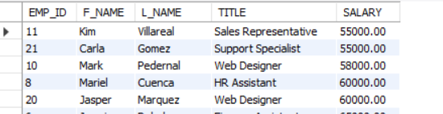

-- 2. List all employees in descending order of their years of service.
SELECT EMP_ID, F_NAME, L_NAME, YEARS_OF_SERVICE
FROM EMPLOYEE_DATA
ORDER BY YEARS_OF_SERVICE DESC;
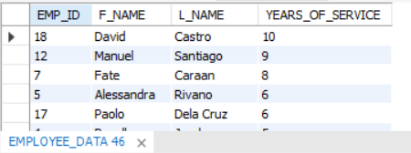

-- 3. What does the following statement display?
SELECT emp_id, l_name, title, age
FROM employee_data
ORDER BY title DESC, age ASC;
-- THIS DISPLAYS ALL EMPLOYEES SORTED PRIMARILY BY JOB TITLE IN DESCENDING ORDER, AND WITHIN EACH TITLE, SORTED BY AGE IN ASCENDING ORDER.
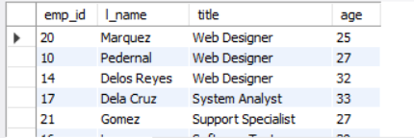

-- 4. Display employees (last names followed by first names) who hold the title of either “Programmer” or “Web Designer” and sort their last names alphabetically.
SELECT CONCAT(L_NAME, ', ', F_NAME) AS FULL_NAME, TITLE
FROM EMPLOYEE_DATA
WHERE TITLE IN ('PROGRAMMER', 'WEB DESIGNER')
ORDER BY L_NAME ASC;
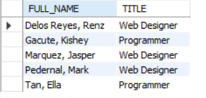

CREATE DATABASE IF NOT EXISTS EXERCISE6_DB;
USE EXERCISE6_DB;
CREATE TABLE EMPLOYEE_DATA (
EMP_ID INT AUTO_INCREMENT PRIMARY KEY,
F_NAME VARCHAR(50),
L_NAME VARCHAR(50),
TITLE VARCHAR(100),
AGE INT,
SALARY DECIMAL(10,2),
YEARS_OF_SERVICE INT
);
INSERT INTO EMPLOYEE_DATA (F_NAME, L_NAME, TITLE, AGE, SALARY, YEARS_OF_SERVICE) VALUES
('Kishey', 'Gacute', 'Programmer', 34, 80000, 4),
('Kim', 'Ricaro', 'Marketing Executive', 33, 90000, 3),
('Trisha', 'Ogbac', 'Sales Associate', 35, 85000, 2),
('Recelle', 'Janda', 'Senior Programmer', 45, 100000, 5),
('Alessandra', 'Rivano', 'Software Engineer', 29, 75000, 6),
('Jamaima', 'Rabulan', 'Finance Assistant', 25, 65000, 1),
('Fate', 'Caraan', 'Marketing Manager', 36, 120000, 8),
('Mariel', 'Cuenca', 'HR Assistant', 28, 60000, 2),
('Melody', 'Monreal', 'Marketing Staff', 30, 65000, 1),
('Mark', 'Pedernal', 'Web Designer', 27, 58000, 2),
('Kim', 'Villareal', 'Sales Representative', 26, 55000, 2),
('Manuel', 'Santiago', 'Marketing Head', 40, 95000, 9),
('Alona', 'Navarro', 'Junior Programmer', 31, 75000, 4),
('Renz', 'Delos Reyes', 'Web Designer', 32, 72000, 5),
('Ella', 'Tan', 'Programmer', 29, 78000, 3),
('Mica', 'Lopez', 'Software Tester', 30, 70000, 2),
('Paolo', 'Dela Cruz', 'System Analyst', 33, 88000, 6),
('David', 'Castro', 'Project Manager', 38, 110000, 10),
('Liza', 'Santos', 'Marketing Coordinator', 28, 68000, 4),
('Jasper', 'Marquez', 'Web Designer', 25, 60000, 1),
('Carla', 'Gomez', 'Support Specialist', 27, 55000, 2);

